Free Vibrations of Simply Supported Beam with Distributed Mass
.
AI generated calculations (as continuous mass system)
Dynamic analysis based on Euler-Bernoulli beam theory
1. Input Data
Beam geometry
Span length - $L=6 \text{m}$
Cross-section (rectangular)
Width - $b=0.3 \text{m}$
Height - $h=0.5 \text{m}$
Cross-section area - $A=b·h=0.3 \text{m}·0.5 \text{m}=0.15 {\text{m}}^{2}$
Second moment of area - $I=\frac{b·h^{3}}{12}=\frac{0.3 \text{m}·{\left(0.5 \text{m}\right)}^{3}}{12}=0.00313 {\text{m}}^{4}$
Material properties
Modulus of elasticity - $E=30 \text{GPa}$
Mass density - $ρ=2500 \frac{\text{kg}}{{\text{m}}^{3}}$
Derived quantities
Bending stiffness - $EI=E·I=30 \text{GPa}·0.00313 {\text{m}}^{4}=0.0938 \text{Mt}\text{·}{\text{m}}^{3}\text{∕}{\text{s}}^{2}$
Distributed mass per unit length - $m=ρ·A=2500 \text{kg}\text{∕}{\text{m}}^{3}·0.15 {\text{m}}^{2}=375 \text{kg}\text{∕}\text{m}$
Total mass of the beam - $M_{tot}=m·L=375 \text{kg}\text{∕}\text{m}·6 \text{m}=2250 \text{kg}$
2. Analytical Solution
Theory
For a simply supported beam with uniformly distributed mass, the equation of free vibrations is:
EI·∂⁴w/∂x⁴ + m·∂²w/∂t² = 0
The solution is obtained by separation of variables:
w(x, t) = φ(x)·q(t)
Mode shapes: φ_{n}(x) = sin(nπx/L)
Natural circular frequencies:
ω_{n} = (nπ/L)² · √(EI/m)
Number of modes to compute
$$n=5$$
3. Natural Frequencies and Periods
Circular frequencies ω_{n}
$$ω\left(k\right)={\left(\frac{k·π}{L}\right)}^{2}·\sqrt{\frac{EI}{m}}$$
Natural frequencies f_{n}
$$f\left(k\right)=\frac{ω\left(k\right)}{2·π}$$
Vibration periods T_{n}
$$T\left(k\right)=\frac{1}{f\left(k\right)}$$
Results for the first $n=5$ modes:
Mode | ω_{n} [rad/s] | f_{n} [Hz] | T_{n} [s]
1 | 137.08 | 21.82 | 0.05
2 | 548.31 | 87.27 | 0.01
3 | 1233.7 | 196.35 | 0.01
4 | 2193.25 | 349.07 | 0
5 | 3426.95 | 545.42 | 0
Fundamental frequency (1st mode)
Circular frequency - $ω_{1}=ω\left(1\right)=137.08 \text{Hz}$
Natural frequency - $f_{1}=f\left(1\right)=21.82 \text{Hz}$
Vibration period - $T_{1}=T\left(1\right)=0.0458 \text{s}$
4. Mode Shapes
The mode shapes are sinusoidal functions:
φ_{n}(x) = sin(nπx/L)
$$φ\left(k;x\right)=\text{sin}\left(\frac{k·π·x}{L}\right)$$
$$PlotHeight=120$$
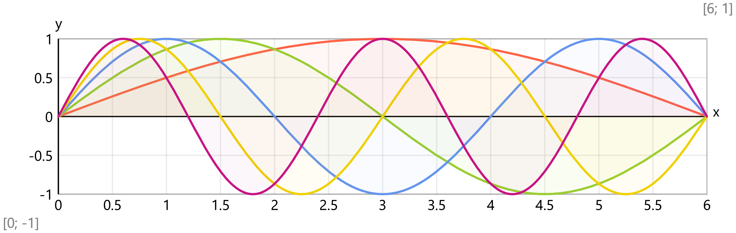
5. Modal Properties
Modal mass
For sinusoidal mode shapes of a simply supported beam:
M_{n} = ∫₀ᴸ m·φ_{n}²(x) dx = m·L/2
$$M_{n}=\frac{m·L}{2}=\frac{375 \text{kg}\text{∕}\text{m}·6 \text{m}}{2}=1125 \text{kg}$$
Modal stiffness
K_{n} = ω_{n}²·M_{n}
Mode | M_{n} [kg] | K_{n} [kN/m]
1 | 1125 | 21139.13
2 | 1125 | 338226.01
3 | 1125 | 1712269.18
4 | 1125 | 5411616.17
5 | 1125 | 13211953.54
6. Free Vibration Response
Initial conditions
Initial midspan displacement - $w_{0}=5 \text{mm}$
Initial velocity - $v_{0}=0 \frac{\text{m}}{\text{s}}$
Response at midspan
For initial displacement w₀ at midspan with zero initial velocity,
the modal initial conditions are:
q_{n}(0) = (2/L)·∫₀ᴸ w₀·δ(x-L/2)·sin(nπx/L) dx
For concentrated initial displacement at midspan:
q_{n}(0) = w₀·sin(nπ/2)·(2/(m·L))
Only odd modes are excited (modes 1, 3, 5,...).
Time history of midspan displacement (first mode approximation)
Amplitude of first mode - $A_{1}=w_{0}=5 \text{mm}$
Response - $w\left(t\right)=A_{1}·\text{sin}\left(\frac{\frac{π·L}{2}}{L}\right)·\text{cos}\left(ω\left(1\right)·t\right)$
$$t_{max}=3·T\left(1\right)=0.138 \text{s}$$
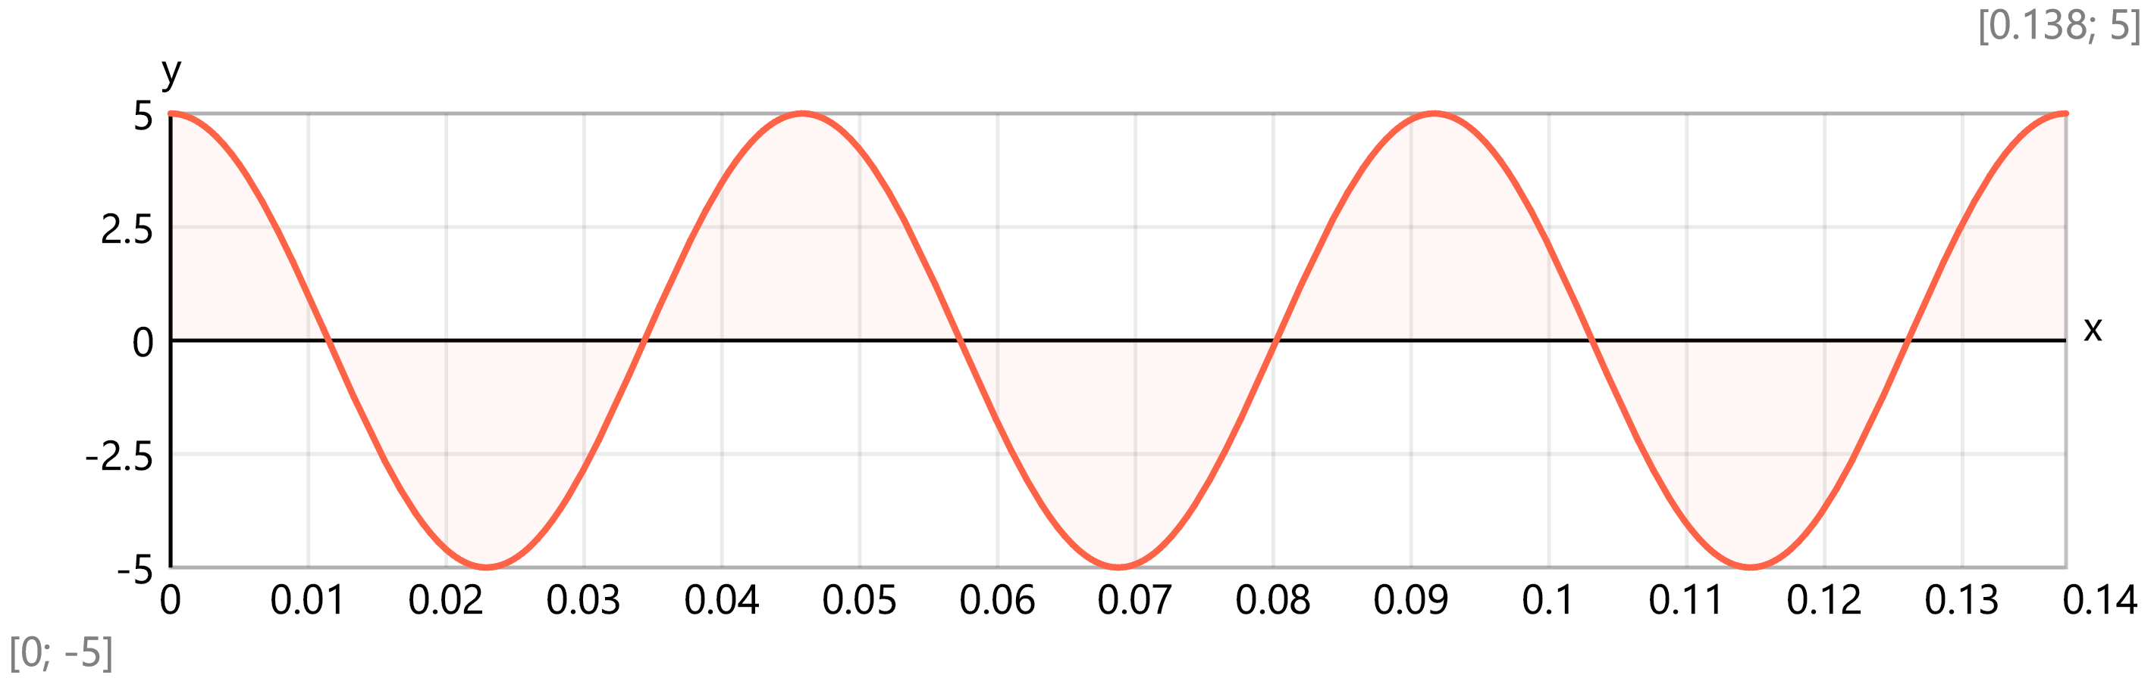
7. Verification
Comparison with approximate formulas
Static deflection under self-weight:
δ_{st} = 5·m·g·L⁴/(384·EI)
$$g=9.81 \frac{\text{m}}{{\text{s}}^{2}}$$
$$δ_{st}=\frac{5·m·g·L^{4}}{384·EI}=\frac{5·375 \text{kg}\text{∕}\text{m}·9.81 \text{m}\text{∕}{\text{s}}^{2}·{\left(6 \text{m}\right)}^{4}}{384·0.0938 \text{Mt}\text{·}{\text{m}}^{3}\text{∕}{\text{s}}^{2}}=0.662 \text{mm}$$
Approximate fundamental frequency (Rayleigh method):
$$f_{1R}=\frac{1}{2·π}·\sqrt{\frac{g}{δ_{st}}}=\frac{1}{2·3.14}·\sqrt{\frac{9.81 \text{m}\text{∕}{\text{s}}^{2}}{0.662 \text{mm}}}=19.37 {\text{s}}^{\text{-}1}$$
Exact fundamental frequency: f₁ = π/(2L²)·√(EI/m)
Ratio (exact/Rayleigh) - $r=\frac{f_{1}}{f_{1R}}=\frac{21.82 \text{Hz}}{19.37 {\text{s}}^{\text{-}1}}=1.13$
The Rayleigh method gives a slightly different result because it uses a static deflection shape (parabolic) instead of the exact sinusoidal mode shape.
8. Frequency Ratios
Relationship between higher modes and fundamental frequency
For a simply supported beam: f_{n}/f₁ = n²
Mode n | f_{n}/f₁ | n²
1 | 1 | 1
2 | 4 | 4
3 | 9 | 9
4 | 16 | 16
5 | 25 | 25
This confirms the characteristic property of simply supported beams:
natural frequencies increase proportionally to the square of the mode number.
Manual verification (as equivalent discrete mass SDOF or MDOF systems)
.
Structure type - simply supported beam
Beam length - $L=6 \text{m}$
Cross section - rectangular with dimensions:
Width - $b=300 \text{mm}$
Height - $h=500 \text{mm}$
Area - $A=b·h=300 \text{mm}·500 \text{mm}=1500 {\text{cm}}^{2}$
Second moment of area - $I=\frac{b·h^{3}}{12}=\frac{300 \text{mm}·{\left(500 \text{mm}\right)}^{3}}{12}=3125000000 {\text{mm}}^{4}$
Shear area - $A_{Q}=\frac{5}{6}·A=\frac{5}{6}·1500 {\text{cm}}^{2}=1250 {\text{cm}}^{2}$
Modulus of elasticity - $E=30 \text{GPa}$
Poisson′s ratio - $ν=0.2$
Shear modulus - $G=\frac{E}{2·\left(1+ν\right)}=\frac{30 \text{GPa}}{2·\left(1+0.2\right)}=12.5 \text{GPa}$
Mass density - $ρ=2500 \frac{\text{kg}}{{\text{m}}^{3}}$
Distributed mass per unit length - $m=ρ·A=2500 \text{kg}\text{∕}{\text{m}}^{3}·1500 {\text{cm}}^{2}=375 \text{kg}\text{∕}\text{m}$
Simple solution as equivalent SDOF system
The structure is reduced to a SDOF system for simplicity
Dynamically equivalent mass - $M_{tot}=\frac{2·L}{π}·m=\frac{2·6 \text{m}}{3.14}·375 \text{kg}\text{∕}\text{m}=1432.39 \text{kg}$
Structural stiffness for a vertical force applied at the middle point of the span
$$K=\frac{48·E·I}{L^{3}}=\frac{48·30 \text{GPa}·3125000000 {\text{mm}}^{4}}{{\left(6 \text{m}\right)}^{3}}=20833.3 \text{kN}\text{∕}\text{m}$$
Natural circular frequency - $ω_{1}=\sqrt{\frac{K}{M_{tot}}}=\sqrt{\frac{20833.3 \text{kN}\text{∕}\text{m}}{1432.39 \text{kg}}}=120.6 {\text{s}}^{\text{-}1}$
Vibration frequency - $f_{1}=\frac{ω_{1}}{2·π}=\frac{120.6 {\text{s}}^{\text{-}1}}{2·3.14}=19.19 {\text{s}}^{\text{-}1}$
Vibration period - $T_{1}=\frac{2·π}{ω_{1}}=\frac{2·3.14}{120.6 {\text{s}}^{\text{-}1}}=0.0521 \text{s}$
Solution as an MDOF system
Number of intermediate joints - $n_{J}=11$
Length of one segment - $Δx=\frac{L}{n_{J}+1}=\frac{6 \text{m}}{11+1}=0.5 \text{m}$
Coordinate of joint j - $x_{J}\left(j\right)=Δx·j$
Shear forces due to unit vertical load F_{j} = 1 at joint j
$$V_{1}\left(x;j\right)=\{\begin{matrix}\text{ if }x<x_{J}\left(j\right): & 1-\frac{x_{J}\left(j\right)}{L} \\ \text{ else:} & \frac{\text{-}x_{J}\left(j\right)}{L}\end{matrix}$$
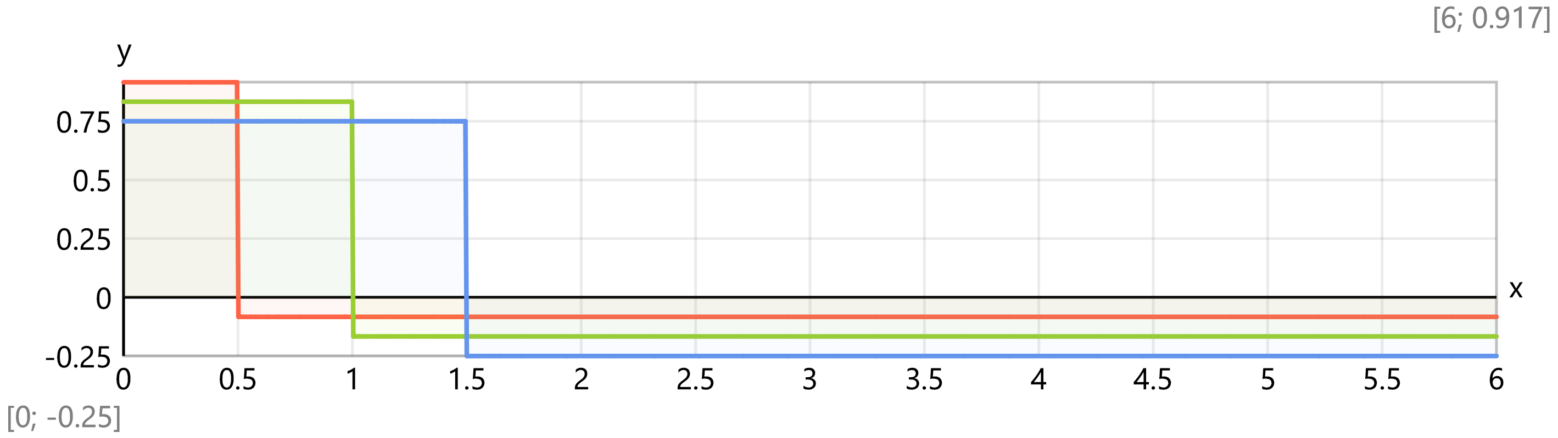
Bending moments due to unit vertical load F_{j} = 1 at joint j
$$M_{1,max}\left(j\right)=\left(\frac{x_{J}\left(j\right)}{L}-1\right)·x_{J}\left(j\right)$$
$$M_{1}\left(x;j\right)=M_{1,max}\left(j\right)·\left(\{\begin{matrix}\text{ if }x<x_{J}\left(j\right): & \frac{x}{x_{J}\left(j\right)} \\ \text{ else:} & \frac{L-x}{L-x_{J}\left(j\right)}\end{matrix} \right)$$
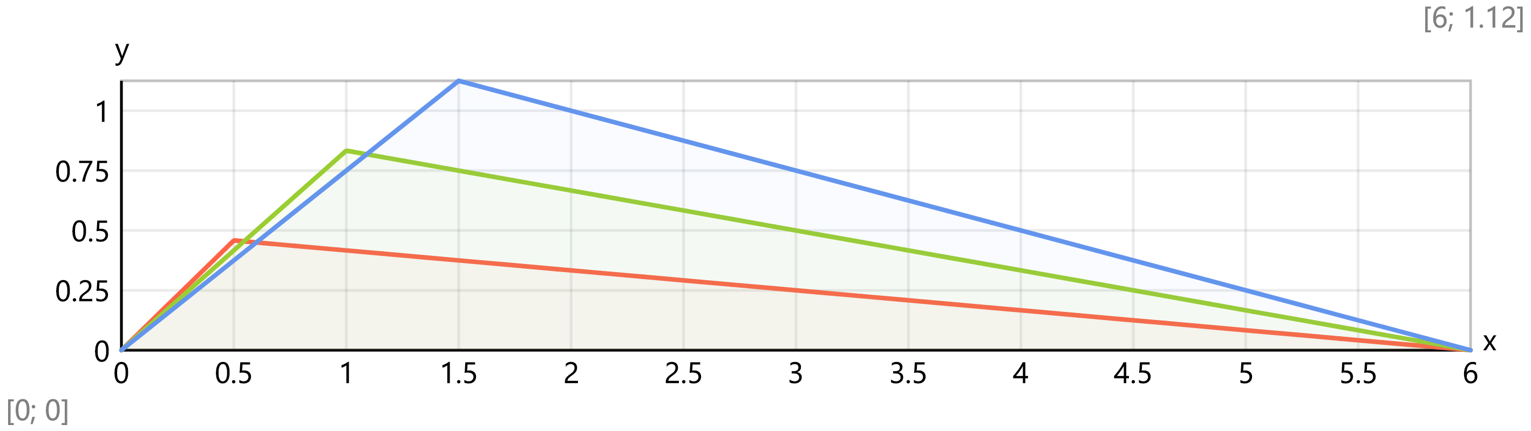
Flexibility matrix
$D\left(i;j\right)=\left(\int_{0 \text{m}}^{L}{M_{1}\left(x;i\right)·M_{1}\left(x;j\right) dx}\right)·\frac{1}{E·I}$ + $Area{V_1(x; i)*V_1(x; j) @ x = 0m : L}*(1/(G*A_Q)) (skipped for compatibility)
$D=\left[\begin{matrix}0.00448 & 0.00796 & 0.0103 & 0.0117 & 0.0122 & 0.0119 & 0.0109 & 0.00941 & 0.00744 & 0.00515 & 0.00263 \\ 0.00796 & 0.0148 & 0.0197 & 0.0225 & 0.0236 & 0.0231 & 0.0213 & 0.0184 & 0.0146 & 0.0101 & 0.00515 \\ 0.0103 & 0.0197 & 0.027 & 0.0316 & 0.0334 & 0.033 & 0.0306 & 0.0264 & 0.021 & 0.0146 & 0.00744 \\ 0.0117 & 0.0225 & 0.0316 & 0.0379 & 0.041 & 0.0409 & 0.0381 & 0.0332 & 0.0264 & 0.0184 & 0.00941 \\ 0.0122 & 0.0236 & 0.0334 & 0.041 & 0.0454 & 0.0461 & 0.0435 & 0.0381 & 0.0306 & 0.0213 & 0.0109 \\ 0.0119 & 0.0231 & 0.033 & 0.0409 & 0.0461 & 0.048 & 0.0461 & 0.0409 & 0.033 & 0.0231 & 0.0119 \\ 0.0109 & 0.0213 & 0.0306 & 0.0381 & 0.0435 & 0.0461 & 0.0454 & 0.041 & 0.0334 & 0.0236 & 0.0122 \\ 0.00941 & 0.0184 & 0.0264 & 0.0332 & 0.0381 & 0.0409 & 0.041 & 0.0379 & 0.0316 & 0.0225 & 0.0117 \\ 0.00744 & 0.0146 & 0.021 & 0.0264 & 0.0306 & 0.033 & 0.0334 & 0.0316 & 0.027 & 0.0197 & 0.0103 \\ 0.00515 & 0.0101 & 0.0146 & 0.0184 & 0.0213 & 0.0231 & 0.0236 & 0.0225 & 0.0197 & 0.0148 & 0.00796 \\ 0.00263 & 0.00515 & 0.00744 & 0.00941 & 0.0109 & 0.0119 & 0.0122 & 0.0117 & 0.0103 & 0.00796 & 0.00448\end{matrix}\right]$ mm/kN
Mass matrix
$$d_{M.j}=\frac{m·Δx}{\text{t}}=\frac{375 \text{kg}\text{∕}\text{m}·0.5 \text{m}}{\text{t}}=0.188$$
$$M=\left[\begin{matrix}0.188 & 0 & 0 & 0 & 0 & 0 & 0 & 0 & 0 & 0 & 0 \\ 0 & 0.188 & 0 & 0 & 0 & 0 & 0 & 0 & 0 & 0 & 0 \\ 0 & 0 & 0.188 & 0 & 0 & 0 & 0 & 0 & 0 & 0 & 0 \\ 0 & 0 & 0 & 0.188 & 0 & 0 & 0 & 0 & 0 & 0 & 0 \\ 0 & 0 & 0 & 0 & 0.188 & 0 & 0 & 0 & 0 & 0 & 0 \\ 0 & 0 & 0 & 0 & 0 & 0.188 & 0 & 0 & 0 & 0 & 0 \\ 0 & 0 & 0 & 0 & 0 & 0 & 0.188 & 0 & 0 & 0 & 0 \\ 0 & 0 & 0 & 0 & 0 & 0 & 0 & 0.188 & 0 & 0 & 0 \\ 0 & 0 & 0 & 0 & 0 & 0 & 0 & 0 & 0.188 & 0 & 0 \\ 0 & 0 & 0 & 0 & 0 & 0 & 0 & 0 & 0 & 0.188 & 0 \\ 0 & 0 & 0 & 0 & 0 & 0 & 0 & 0 & 0 & 0 & 0.188\end{matrix}\right]$$
Total mass of the structure - $\text{sum}\left({\vec{d}}_{M}\right)=2.06$ t
Eigenvalues
$$M_{sq}=\sqrt{M}=\left[\begin{matrix}0.433 & 0 & 0 & 0 & 0 & 0 & 0 & 0 & 0 & 0 & 0 \\ 0 & 0.433 & 0 & 0 & 0 & 0 & 0 & 0 & 0 & 0 & 0 \\ 0 & 0 & 0.433 & 0 & 0 & 0 & 0 & 0 & 0 & 0 & 0 \\ 0 & 0 & 0 & 0.433 & 0 & 0 & 0 & 0 & 0 & 0 & 0 \\ 0 & 0 & 0 & 0 & 0.433 & 0 & 0 & 0 & 0 & 0 & 0 \\ 0 & 0 & 0 & 0 & 0 & 0.433 & 0 & 0 & 0 & 0 & 0 \\ 0 & 0 & 0 & 0 & 0 & 0 & 0.433 & 0 & 0 & 0 & 0 \\ 0 & 0 & 0 & 0 & 0 & 0 & 0 & 0.433 & 0 & 0 & 0 \\ 0 & 0 & 0 & 0 & 0 & 0 & 0 & 0 & 0.433 & 0 & 0 \\ 0 & 0 & 0 & 0 & 0 & 0 & 0 & 0 & 0 & 0.433 & 0 \\ 0 & 0 & 0 & 0 & 0 & 0 & 0 & 0 & 0 & 0 & 0.433\end{matrix}\right]$$
$$C=\text{copy}\left(M_{sq}·D·M_{sq};\text{symmetric}\left(n_{J}\right);1;1\right)=\text{copy}\left(M_{sq}·D·M_{sq};\text{symmetric}\left(11\right);1;1\right)=\left[\begin{matrix}0.00084 & 0.00149 & 0.00194 & 0.00219 & 0.00228 & 0.00223 & 0.00205 & 0.00176 & 0.0014 & 0.000965 & 0.000493 \\ 0.00149 & 0.00278 & 0.00369 & 0.00422 & 0.00442 & 0.00433 & 0.00399 & 0.00344 & 0.00273 & 0.00189 & 0.000965 \\ 0.00194 & 0.00369 & 0.00506 & 0.00592 & 0.00627 & 0.00619 & 0.00573 & 0.00496 & 0.00394 & 0.00273 & 0.0014 \\ 0.00219 & 0.00422 & 0.00592 & 0.00711 & 0.00768 & 0.00767 & 0.00715 & 0.00622 & 0.00496 & 0.00344 & 0.00176 \\ 0.00228 & 0.00442 & 0.00627 & 0.00768 & 0.00851 & 0.00865 & 0.00816 & 0.00715 & 0.00573 & 0.00399 & 0.00205 \\ 0.00223 & 0.00433 & 0.00619 & 0.00767 & 0.00865 & 0.009 & 0.00865 & 0.00767 & 0.00619 & 0.00433 & 0.00223 \\ 0.00205 & 0.00399 & 0.00573 & 0.00715 & 0.00816 & 0.00865 & 0.00851 & 0.00768 & 0.00627 & 0.00442 & 0.00228 \\ 0.00176 & 0.00344 & 0.00496 & 0.00622 & 0.00715 & 0.00767 & 0.00768 & 0.00711 & 0.00592 & 0.00422 & 0.00219 \\ 0.0014 & 0.00273 & 0.00394 & 0.00496 & 0.00573 & 0.00619 & 0.00627 & 0.00592 & 0.00506 & 0.00369 & 0.00194 \\ 0.000965 & 0.00189 & 0.00273 & 0.00344 & 0.00399 & 0.00433 & 0.00442 & 0.00422 & 0.00369 & 0.00278 & 0.00149 \\ 0.000493 & 0.000965 & 0.0014 & 0.00176 & 0.00205 & 0.00223 & 0.00228 & 0.00219 & 0.00194 & 0.00149 & 0.00084\end{matrix}\right]$$
$$\vec{λ}=\text{eigenvals}\left(C·{10}^{\text{-}3};\text{-}7\right)=\left[5.32\text{×}{10}^{\text{-}5} 3.33\text{×}{10}^{\text{-}6} 6.57\text{×}{10}^{\text{-}7} 2.08\text{×}{10}^{\text{-}7} 8.57\text{×}{10}^{\text{-}8} 4.17\text{×}{10}^{\text{-}8} 2.29\text{×}{10}^{\text{-}8}\right]$$
Natural circular frequences - $\vec{ω}=\sqrt{\frac{1}{\vec{λ}}}=\left[137.08 548.28 1233.32 2190.89 3416.68 4898.98 6609.4\right]$ s⁻¹
Natural vibration frequences - $\vec{f}=\frac{\vec{ω}}{2·π}·\text{Hz}=\frac{\vec{ω}}{2·3.14}·\text{Hz}=\left[21.82\text{Hz} 87.26\text{Hz} 196.29\text{Hz} 348.69\text{Hz} 543.78\text{Hz} 779.7\text{Hz} 1051.92\text{Hz}\right]$
Natural vibration periods - $\vec{T}=\frac{1}{\vec{f}}=\left[0.0458\text{s} 0.0115\text{s} 0.00509\text{s} 0.00287\text{s} 0.00184\text{s} 0.00128\text{s} 0.000951\text{s}\right]$
Eigenvectors
$$V=\text{transp}\left(\text{eigenvecs}\left(C·{10}^{\text{-}3};\text{-}7\right)\right)=\left[\begin{matrix}0.106 & 0.204 & 0.289 & 0.354 & 0.394 & 0.408 & 0.394 \\ 0.204 & 0.354 & 0.408 & 0.354 & 0.204 & \text{-}6\text{×}{10}^{\text{-}14} & \text{-}0.204 \\ 0.289 & 0.408 & 0.289 & 0 & \text{-}0.289 & \text{-}0.408 & \text{-}0.289 \\ 0.354 & 0.354 & 0 & \text{-}0.354 & \text{-}0.354 & 9.54\text{×}{10}^{\text{-}14} & 0.354 \\ 0.394 & 0.204 & \text{-}0.289 & \text{-}0.354 & 0.106 & 0.408 & 0.106 \\ 0.408 & 0 & \text{-}0.408 & 0 & 0.408 & \text{-}1.04\text{×}{10}^{\text{-}14} & \text{-}0.408 \\ 0.394 & \text{-}0.204 & \text{-}0.289 & 0.354 & 0.106 & \text{-}0.408 & 0.106 \\ 0.354 & \text{-}0.354 & 0 & 0.354 & \text{-}0.354 & 8.73\text{×}{10}^{\text{-}15} & 0.354 \\ 0.289 & \text{-}0.408 & 0.289 & \text{-}1.48\text{×}{10}^{\text{-}14} & \text{-}0.289 & 0.408 & \text{-}0.289 \\ 0.204 & \text{-}0.354 & 0.408 & \text{-}0.354 & 0.204 & \text{-}5.96\text{×}{10}^{\text{-}14} & \text{-}0.204 \\ 0.106 & \text{-}0.204 & 0.289 & \text{-}0.354 & 0.394 & \text{-}0.408 & 0.394\end{matrix}\right]$$
$$Φ=\text{inverse}\left(M_{sq}\right)·V=\left[\begin{matrix}0.244 & 0.471 & 0.667 & 0.816 & 0.911 & 0.943 & 0.911 \\ 0.471 & 0.816 & 0.943 & 0.816 & 0.471 & \text{-}1.39\text{×}{10}^{\text{-}13} & \text{-}0.471 \\ 0.667 & 0.943 & 0.667 & 0 & \text{-}0.667 & \text{-}0.943 & \text{-}0.667 \\ 0.816 & 0.816 & 0 & \text{-}0.816 & \text{-}0.816 & 2.2\text{×}{10}^{\text{-}13} & 0.816 \\ 0.911 & 0.471 & \text{-}0.667 & \text{-}0.816 & 0.244 & 0.943 & 0.244 \\ 0.943 & 0 & \text{-}0.943 & 0 & 0.943 & \text{-}2.39\text{×}{10}^{\text{-}14} & \text{-}0.943 \\ 0.911 & \text{-}0.471 & \text{-}0.667 & 0.816 & 0.244 & \text{-}0.943 & 0.244 \\ 0.816 & \text{-}0.816 & 0 & 0.816 & \text{-}0.816 & 2.02\text{×}{10}^{\text{-}14} & 0.816 \\ 0.667 & \text{-}0.943 & 0.667 & \text{-}3.41\text{×}{10}^{\text{-}14} & \text{-}0.667 & 0.943 & \text{-}0.667 \\ 0.471 & \text{-}0.816 & 0.943 & \text{-}0.816 & 0.471 & \text{-}1.38\text{×}{10}^{\text{-}13} & \text{-}0.471 \\ 0.244 & \text{-}0.471 & 0.667 & \text{-}0.816 & 0.911 & \text{-}0.943 & 0.911\end{matrix}\right]$$
$$X=\text{stack}\left(\text{matrix}\left(1;3\right);Φ;\text{matrix}\left(1;3\right)\right)=\left[\begin{matrix}0 & 0 & 0 & 0 & 0 & 0 & 0 \\ 0.244 & 0.471 & 0.667 & 0.816 & 0.911 & 0.943 & 0.911 \\ 0.471 & 0.816 & 0.943 & 0.816 & 0.471 & \text{-}1.39\text{×}{10}^{\text{-}13} & \text{-}0.471 \\ 0.667 & 0.943 & 0.667 & 0 & \text{-}0.667 & \text{-}0.943 & \text{-}0.667 \\ 0.816 & 0.816 & 0 & \text{-}0.816 & \text{-}0.816 & 2.2\text{×}{10}^{\text{-}13} & 0.816 \\ 0.911 & 0.471 & \text{-}0.667 & \text{-}0.816 & 0.244 & 0.943 & 0.244 \\ 0.943 & 0 & \text{-}0.943 & 0 & 0.943 & \text{-}2.39\text{×}{10}^{\text{-}14} & \text{-}0.943 \\ 0.911 & \text{-}0.471 & \text{-}0.667 & 0.816 & 0.244 & \text{-}0.943 & 0.244 \\ 0.816 & \text{-}0.816 & 0 & 0.816 & \text{-}0.816 & 2.02\text{×}{10}^{\text{-}14} & 0.816 \\ 0.667 & \text{-}0.943 & 0.667 & \text{-}3.41\text{×}{10}^{\text{-}14} & \text{-}0.667 & 0.943 & \text{-}0.667 \\ 0.471 & \text{-}0.816 & 0.943 & \text{-}0.816 & 0.471 & \text{-}1.38\text{×}{10}^{\text{-}13} & \text{-}0.471 \\ 0.244 & \text{-}0.471 & 0.667 & \text{-}0.816 & 0.911 & \text{-}0.943 & 0.911 \\ 0 & 0 & 0 & 0 & 0 & 0 & 0\end{matrix}\right]$$
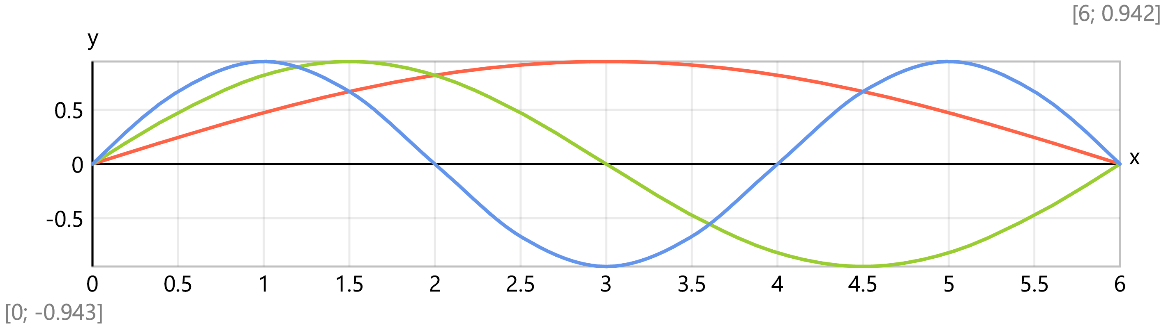
Comparison of the results
AI gen, Hz | Manual, Hz | Difference
21.82 | 21.82 | 0.00%
87.27 | 87.26 | 0.01%
196.35 | 196.29 | 0.03%
349.07 | 348.69 | 0.11%
545.42 | 543.78 | 0.30%

